ORDINANCE NO. 88-2005

AN ORDINANCE OF THE CITY OF TITUSVILLE, FLORIDA, ESTABLISHING THE WILLOW CREEK COMMUNITY DEVELOPMENT DISTRICT PURSUANT TO CHAPTER 190, FLORIDA STATUTES (2005); NAMING THE DISTRICT; DESCRIBING THE EXTERNAL BOUNDARIES OF THE DISTRICT; DESCRIBING THE FUNCTIONS AND POWERS OF THE DISTRICT; DESIGNATING FIVE PERSONS TO SERVE AS THE INITIAL MEMBERS OF THE DISTRICT'S BOARD OF SUPERVISORS; PROVIDING A SEVERABILITY CLAUSE; AND PROVIDING AN EFFECTIVE DATE.

RECITALS

WHEREAS, Willow Creek Residential Community Developers, Inc. ("Petitioner"), having obtained written consent to the establishment of the Willow Creek Community Development District (the "District") by the owner of one-hundred percent (100%) of the real property to be included in the District, petitioned the City Council ("Council") of Titusville, Florida, to adopt an ordinance establishing the District pursuant to Chapter 190, Florida Statutes; and,

WHEREAS, the Petitioner is a corporation authorized to conduct business in the State of Florida whose address is 1682 Hibiscus Blvd., Melbourne, FL 32901; and,

WHEREAS, all interested persons and affected units of general-purpose local government were afforded an opportunity to present oral and written comments on the petition at a duly noticed public hearing conducted by the Council on December 13, 2005; and,

WHEREAS, upon consideration of the record established at that hearing, the Council determined that the statements within the Petition are true and correct; that the establishment of the District is not inconsistent with any applicable element or portion of the state comprehensive plan or the City's comprehensive plan; that the land within the District is of sufficient size; is sufficiently compact and is sufficiently contiguous to be developable as a functionally interrelated community; that the District is the best alternative available for delivering community development services and facilities to the area that will be served by the District; that the community development services and facilities of the District will not be incompatible with the capacity and uses of existing local and regional community development services and facilities; and that the area that will be served by the District is amenable to separate special-district governance; and,

WHEREAS, the establishment of the District shall not act to amend any land development approvals governing the land area to be included within the District; and
WHEREAS, the establishment of the District will constitute a timely, efficient, effective, responsive and economic way to deliver community development services in the area described in the petition; and

Be It Ordained by the City Council of Titusville, Florida:

Section 1. Authority. This ordinance is adopted in compliance with and pursuant to the Uniform Community Development District Act of 1980 codified in Chapter 190, Florida Statutes. Nothing contained herein shall constitute an amendment to any land development approvals for the land area included within the District.

Section 2. District Name. There is hereby created a community development district situated entirely within a portion of the City of Titusville, Florida, which shall be known as the "Willow Creek Community Development District", and which shall be referred to in this ordinance as the "District".

Section 3. District External Boundaries. The external boundaries of the District are described in Appendix A attached hereto, said boundaries encompassing
682.89 acres, more or less. The District is limited to the project site boundaries as indicated in Exhibit 1 of the ordinance or such boundaries as may be amended from time to time.

Section 4. District Powers and Functions. The powers and functions of the District are described in Chapter 190, Florida Statutes. Consent is hereby given to the District's Board of Supervisors to plan, establish, acquire, construct or reconstruct, enlarge or extend, equip, operate, and maintain systems and facilities described and authorized by Section 190.012(2)(a), Florida Statutes. Infrastructure improvements shall be as authorized by Chapter 190, Florida Statutes.

Section 5. Board of Supervisors. The five persons designated to serve as initial members of the District's Board of Supervisors are as follows:

Name: Address:

Name: Address:

Name: Address:

Name: Address:
John C. Bower
1185 Two Oaks Blvd Merritt Island, FL 32952

Brad Smith
2090 W. Eau Gallie Blvd., Suite B Melbourne, FL 32935

Craig Edwards 126 Lagoon Ave
Melbourne, FL 32901

Scott Nickle 100 Parnell St
Merritt Island, FL 32953

Name: Address:
Randall A. Cave 3505 Seaford Land
Casselberry, Fl 32707

Section 6. Notice Requirements. The District shall provide public notice of all meetings pursuant to law. Notices regarding Special Assessments shall be provided in substantially the same form as provided in Composite Exhibit "A" attached hereto, and as required by Chapter 190, Florida Statutes.

Section 7. Special Assessments. Non ad valorem special assessments, as defined in Chapter 190, Florida Statutes, shall only be levied by the District on those lands included within the District boundary, as such boundary may be amended, and in accordance with Chapter 190, Florida Statutes.

Section 8. Severability. If any provision of this ordinance, or the application thereof, is finally determined by a court of competent jurisdiction to be invalid, illegal or unenforceable, such provision shall be deemed to be severable and the remaining provisions shall continue in full force and effect provided that the invalid, illegal or unenforceable provision is not material to the logical and intended interpretation of this ordinance.

Section 9. Effective Date. This ordinance shall become effective upon adoption.

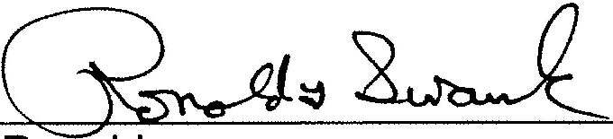
PASSED AND ADOPTED this 19th day of December, 2005.

Ronald G. Swank, Mayor


ATTEST:
'LJ<1,ida \l k
Wanda F. Wells, City Clerk

Appendix A [District's External Boundaries]

HWY | KINGS HWY
HWY | PORT ST. JOHN

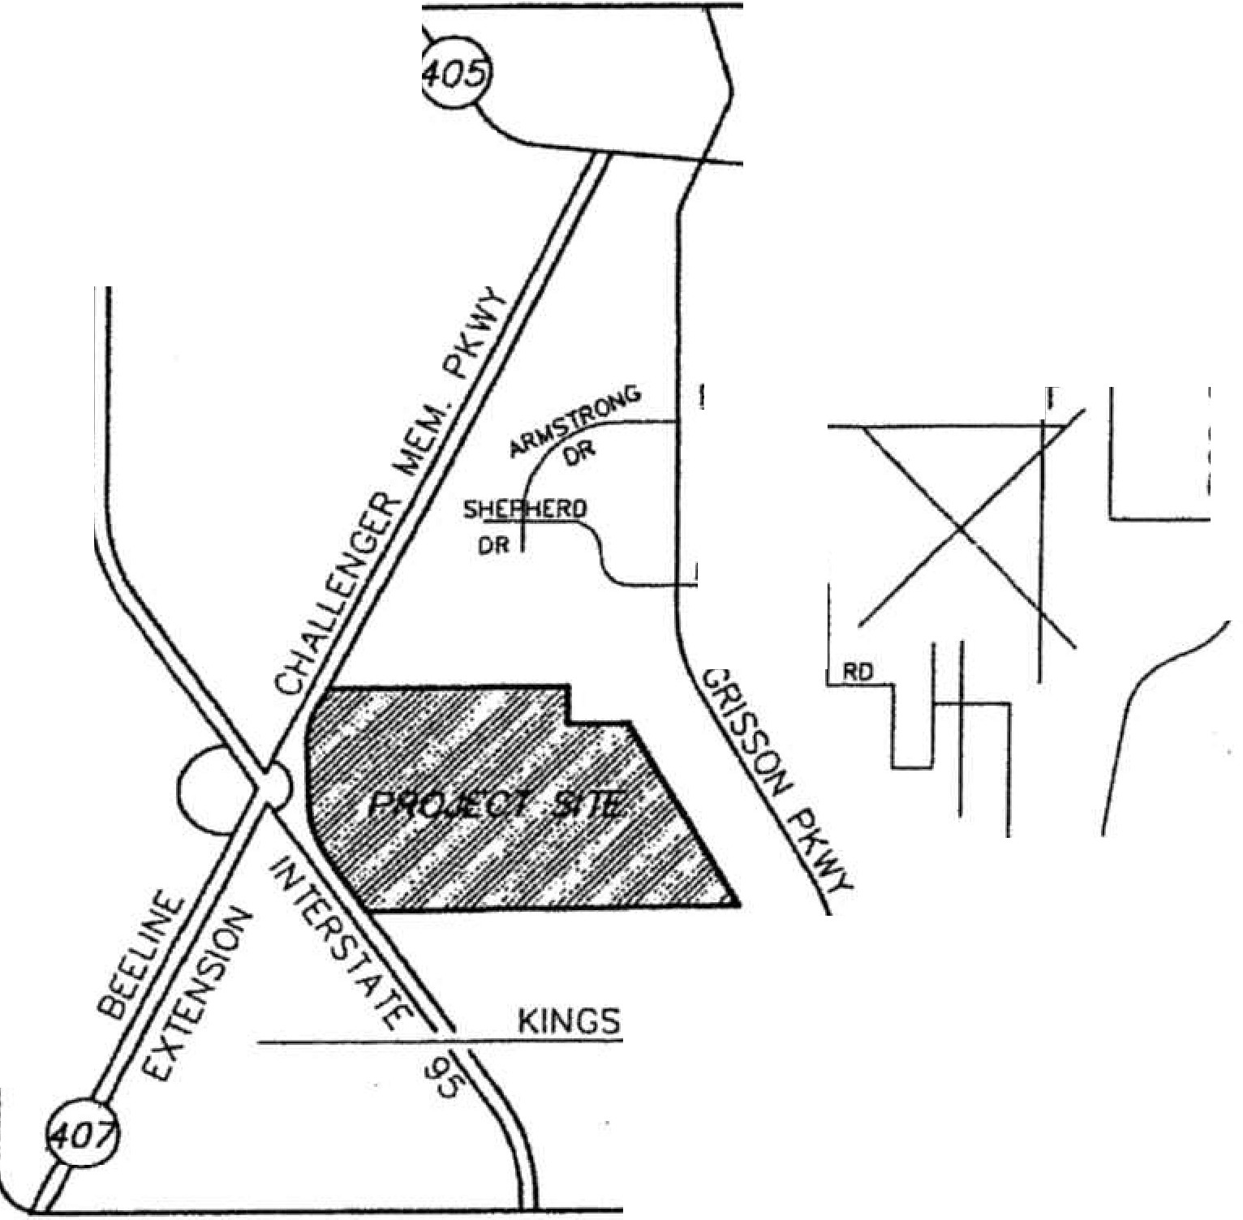
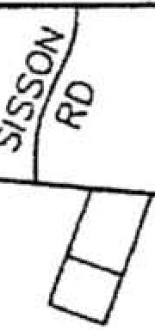
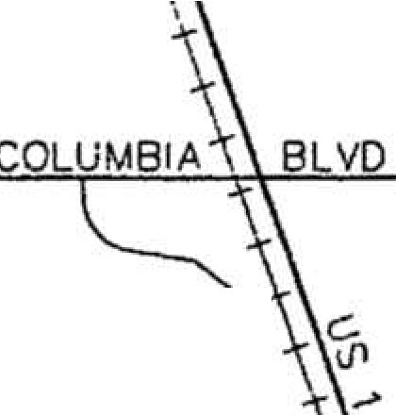
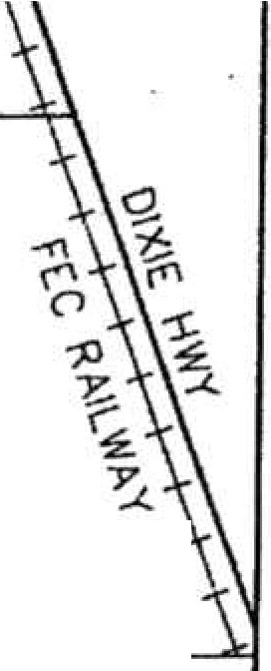
LOCATlON MAP
'MNOOVER FARMS
t­
<{
t­
w
a::
i/)
w
zt-
.:."\ =--......
SPACE COAST EXECUTIVE AIRPOR
0
a:: ---1, ---
0
F
u
PE:IW,IETOI
N. T.S.
EXHIBIT 1

LEGAL DESCRIPTION: PROPOSED WILLOW CREEK CDD LEGAL (BY SURVEYOR)

A parcel of land being Lots 184, 185, 186, 191, 192, 193, 200, 201, 208, 209, 216
and 217 together with portions of Lots 177, 178, 179, 182, 183, 187, 190, 194, 195,
199, 202, 207, 210, 215, 218, 223 and 224 as shown on the Plat of Cocoa-Indian River Properties as recorded in Plat Book 5, Page 7 of the Public Records of Brevard County, Florida.

Together with:

A portion of the North 3/4 of Section 9, Township 23 South, Range 35 East, Brevard County, Florida lying East of the Easterly Right-of-Way line Interstate 95 and State Road No. 407.

Together with:

A portion of the South 1/2 of Section 4, Township 23 South, Range 35 East lying East of the Easterly line of State Road No. 407.

Together with:

Tract R-4, Willow Creek Commercial Center Phase I, according to the Plat thereof, as recorded in Plat Book 51, Pages 20-26, of the Public Records of Brevard County, Florida.

All of the above·being more particularly described as follows:

Commence at the Southeast corner of Section 10, Township 23 South, Range 35 East, Brevard County, Florida; thence North 00°11'12" East along the East line of said Section 10, a distance of 1327.76 feet to the Northeast corner of the South 1/4 of said Section 10; thence continue North 00°11'12'' East along said East line of Section 10, a distance of 101.45 feet; thence South 89°22'09" West, distance of 316.46 feet to a point lying on the Westerly Right-of-Way line of Grissom Parkway as described in O.R. Book 2721, Page 910, of the said Public Records of Brevard County, Florida; thence continue South 89°22'09" West, distance of 1608.67 feet to the Point-of-Beginning of the herein described parcel of land; thence continue South 89°22'09" West along said line, a distance of 7,192.35 Feet to a point on the East Right-of-Way line of Interstate 95; thence run along the East Right-of-Way line of Interstate 95 and State Road 407 (a.k.a. Challenger Memorial Parkway) as shown on Florida Department of Transportation Right-of-Way Map Section 7006-2501 for the following seven calls:
a
a
North 35°26'31" West, a distance of 1,079.54 Feet; thence North 31°25'51" West, a
distance of 461.53 Feet to the point of curvature of a circular curve concave to the East, having a radius of 1,819.86 Feet, and a central angle of 28°53'59"; thence Northerly along the arc of said curve an arc distance of 917.93 Feet; thence North

02°31'52" West, a distance of 1,179.02 Feet to the point of curvature of a circular curve concave to the East, having a radius of 1,342.40 Feet, and a central angle of 32°21'46"; thence Northerly along the arc of said curve an arc distance of 758.24 Feet; thence North 29°49'54" East, a distance of·198.99 Feet; thence Norlh 30°59'13" East, a distance of 268.32 Feet; thence leaving said East Right-of-Way line run North 89°52'19" East, a distance of 2,962.61 Feet; thence North 00°20'28" West, a distance of 1,948.46 Feet to the point of curvature of a circular curve- · con cave to the Southeast, having a radius of 510.00 Feet, and a central angle of 89°04'25"; thence Northeasterly along the arc of said curve an arc distance of
792.86 Feet to the point of reverse curvature of a circular curve concave to the Northwest having a radius of 215.00 Feet, and a central angle of 88°29'47"; thence Northeasterly along the arc of said curve an arc distance of 332.08 Feet; thence North 00°14'10" East, a distance of 9.80 Feet to the Southea$t comer of Tract D, Enterprise Park, according to the Plat thereof, as recorded In Plat Book 32, Page
74, of the Public Records of Brevard County, Florida; thence South 89°52'14" East along the South line of said Enterprise Park, a distance of 120.00 Feet to the Southwest comer of Tract C of said Enterprise Park; thence leaving said South line run South 00°14'10" West, a distance of 10.02 Feet to the point of curvature of a circular curve concave to the Northwest, having a radius of 335.00 Feet, and a central angle of 88°29'47"; thence Southwesterly along the arc of said curve an arc distance of 517.43 Feet to the point of reverse curvature of a circular curve concave to the Southeast having a radius of 390.00 Feet, and a central angle of 89°04'25"; thence Southwesterly along the arc of said curve an arc distance of
606.31 Feet; thence South 00°20'28" East, a distance of 1,948.91 Feet; thence North 89°52'19" East, a distance of 1,494.00 Feet to a point on the East line of the Southeast 1/4 of said Section 4 and the West line of said Plat of Cocoa-Indian River Properties; thence South 00°24'39" East along said East and West line, a distance of 731.37 Feet to the Southeast corner of said Section 4 and said point· being the Southwest cor:ner of Lot 225 of said Plat of Cocoa-Indian River Properties; thence South 89°50'05" East along the North line of said Section 10 and the South line of said Lot 225, a distance of 1,188.05 Feet to the Northwest corner of Tract 1, of said Willow Creek Commercial Center Phase I; thence So th 31°01'11" East along the West line of said Tract 1, a distance of 3,213.07 Feet to the Southeast corner of said Tract 1; thence North 58°58'49" East along the Sotith line of said Tract 1, a distance of 500.56 Feet to the Southeast corner of said Tract
1, said point being on the West line of Lot 9 of said Willow Cre k Commer iat '· r_
Center Phase I; thence South 28°52'20" East along said West line, a distance-of
15.01 Feet to the Southwest comer of said Lot 9; thence South 31°01'11" East along the Northerly extension of Lot 6, of said Willow Creek Commercial Center
Phase I, a distance of 115.00 Feet to the Northeast corner of Tract 0-1, of sijicf " _ = - c _-,=-·: ;
Willow Creek Commercial Center Phase I; thence South 58°58'49" West along the= •·· -·--:.· ·c-·•_r ',-
North line of said Tract 0-1 and the North line of Tract 3,of said Willow Crci_e-k · -' - ,- ;= '.- '
Commercial Center Phase I, a distance of 500.00 Feet to the Northwest comeh:if · ·- -
said Tract 3; thence South 31°01'11" East along the West line of said Tract 3\ a - _ .. _ · . • · · - · - · distance of 911.11 Feet to the POINT-OF-BEGINNING. :
Containing 682.89 Acres of land more or less.

